CGAPRO WITH BOX MATCHING AND FFP REPORT

CLIENT (24BUNKER)
24" LIGHT CRUDE Pipeline - 24BUNKER
DOCK#1 to IRVING OIL REFINERY

PROJECT NUMBER: 0-1001-18338
REVISION No.: 0
REVISION DATE: NOV 11, 2026

pREPARED by:
Author Mohammad Razzak
QA KRISTIN WONG
Approver JIM SHE

© ROSEN GROUP 2026
CONFIDENTIALITY AND COPYRIGHT
This report (including any enclosures, attachments and digital deliverables) (the “Report”) has been prepared for the exclusive use and benefit of the addressee(s) and solely for the purpose for which it is provided. Nothing in this Report should be considered a guarantee or warranty of the correctness or completeness of data or conclusions contained herein. Unless ROSEN provides express prior written consent, no part of this Report should be reproduced, distributed or otherwise communicated to any third party. ROSEN does not accept any liability if this Report is used for an alternative purpose from which it is intended, nor shall ROSEN have any liability to any third party in respect of this Report. ROSEN collects data using various physical principles. ROSEN process this data in various ways to produce reports that include but are not limited to text, images, tables, listings, and graphs. The data processing ROSEN completes includes but is not limited to integration with other data, distance adaptation, noise filtering, interpolation, and calculations.

Executive Summary
The following section summarises the assessment findings completed in accordance with the scope of work (Appendix A) [1]. Assessment findings are also provided in the accompanying Excel listings ('NPS 24 Refinery to Dock #1 Bunker Pipeline (24BUNKER)_CSA Z662_Compliance_Rev0.xlsx’, 'NPS 24 Refinery to Dock #1 Bunker Pipeline (24BUNKER)_CGApro_BM_Listing_Rev0.xlsx'). The assessment methodologies and relevant industry references are detailed in the ROSEN Standard Methodology Document for Fitness-for-Purpose Assessment (FFP) and Corrosion Growth Assessment (CGA) services [2].
Metal Loss Immediate Integrity
- All reported metal loss anomalies were acceptable for operation at the time of the 2026 in-line inspection (ILI) (see Table 14).
CGA^{pro} Results
- Based on the CGA^{pro} results, one external corrosion growth segment (EC1) was defined, as summarised below:
Segment ID | Start Log Distance  (ft) | End Log Distance  (ft) | Recommended CGR  (mils/year)
EC1 | -5.648 | 8,900.482 | 14.9
- Signal comparisons of four non-corrosion metal-loss anomalies identified two with no clear depth change between the 2020 and 2026 inspections (Signal Comparisons 4 and 22), one with possible growth (Signal Comparison 20), and one with an inconclusive result (Signal Comparison 29).
Metal Loss Future Integrity
- 61 external corrosion anomalies reported by the 2026 ILI are listed for investigation / repair within five years. Of these, 54 have reported repairs before and after 2020 ILI.
- The earliest predicted repair date is July 2026 (0.2 years after the FFP assessment date). This relates to two anomalies with reported depths of 79% wt located at log distances 929.973 m and 1,503.851 m. The anomaly at 929.973 m is reported under a patch, and the anomaly at 1,503.851 m is reported under a patch and sleeve.
Geometric Anomalies
- The geometric anomalies were analyzed in the ILI comparison using box matching. Of the 196 geometric anomalies reported by the 2026 ILI, 180 were matched to anomalies reported by the 2020 inspection and 16 were identified in the previous signal data.
- Each geometric anomaly was evaluated against the static assessment criteria to determine its significance to pipeline integrity at the time of the 2026 ILI. Four dents, at log distances 4,741.287 ft, 6,020.088 ft, 7,307.854 ft and 8,773.554 ft, were found to have unacceptable strain and require further assessment (see Table 15 for further details). Geohazard interaction and IMU bending strain should also be reviewed for all 196 dents.
- 40 dents have estimated fatigue lives of less than 100 years in the current SSI workbook: 25 non-complex dents and 15 complex dents. These preliminary results are affected by incorrect cross-row diameter-to-wall-thickness references. The complex dents require separate fatigue assessment.
- Fatigue-life conclusions for weld-interacting dents are contingent on the assumption that welds are ductile and dents are free from associated cracking or gouging. For dents which fail the immediate screening assessments, fatigue lives are provided for informational purposes only and are contingent on confirmation of the absence of cracking/gouging.
Laminations
- Each lamination was assessed against the static assessment criteria to determine its significance with respect to the integrity of the pipeline at the time of the 2026 ILI. Based on the current screening results, 2 laminations were identified as requiring axial threat assessment and 30 laminations as requiring crack assessment (see Table 16 for further details).
Other Integrity Related Issues
- The ILI data review identified a number of potential threats which require further action or assessment. Details are provided in Table 1.
Recommendations
Table 1: Recommended Actions
Rehabilitation | Irving should follow the repair plan provided. 61 external corrosion anomalies are listed for investigation or repair within five years of the 2026 ILI (Table 17). Further details of these anomalies are provided in the '5 yr - Indiv Anomalies' worksheet of the associated CSA Z662 compliance workbook.  It would be prudent of Irving to verify the repair status of any anomaly prior to undertaking any in-field investigation.
External Corrosion | Based on the results of this assessment it is recommended that Irving review whether the pipeline is susceptible to selective seam weld corrosion. If the threat is credible, an MFL-C inspection capable of identifying selective seam weld corrosion should be considered.
Geometric Anomalies | For any dents assessed as having a higher likelihood of external interference (e.g., TOL dents), the likelihood of associated gouging should also be evaluated by following this process:  Consult records (i.e., surveillance reports, land access records) to determine if the dents are located in an area at risk from external interference.  Perform a gouging susceptibility study using ILI signal data and other complementary data sets to categorise dents based on likelihood of gouging.  Monitor dents where the risk of external interference is considered low.  For dents located in areas at high risk from external interference or deemed likely to be associated with gouging, carry out a local targeted above-ground coating survey to determine the presence of any damage to the coating. The absence of coating damage would provide confidence that the dents are not associated with external interference/gouging.  If coating damage is identified, the dents should be excavated in order to determine their origin and significance, and a suitable repair should then be installed if required.  For the 4 dents with reported unacceptable weld strain, complete further assessment or in-field investigation to determine association with cracking (see Table 15 for details).  41 dents are associated with welds, for these dents:  Review construction or fabrication records to confirm whether the affected weld(s) are ductile or brittle. Repair any dent associated with a brittle weld.  Provided the welds are ductile the assessment identified 4 dents associated with welds which require further assessment to establish the absence of cracking (see Table 15 for details) or in-field investigation to determine association with cracking.  The 71 unrepaired complex-geometry dents and 26 non-complex weld-interacting dents listed for Level 2 fatigue assessment in the CSA compliance assessment should be assessed using a more refined assessment method e.g. Linear-elastic FEA based fatigue assessment, PRCI MD-4-9, Level 3 Assessment as described in API RP 1183. Alternatively, these dents should be investigated in field to determine associated cracking and repair and restrain/drill (to equalise pressure) to mitigate against further fatigue damage.
Laminations | API 579 requires that all surface‑breaking or sloping laminations (Table 16) are assessed as crack‑like flaws. The current screening identifies 30 laminations for crack assessment and 2 for axial threat assessment.  For the 2 laminations identified for axial threat assessment (Table 16), Irving should determine whether axial loading is a credible threat at the affected location(s). Where no credible axial loading threat exists, no further action is generally required.  If axial loading is identified as a potential threat, a more detailed review of crossings, existing mitigation measures, and relevant geotechnical conditions may be necessary. Field investigations should be limited to those locations assessed as having the highest susceptibility.
Other Integrity Related Issues | Regarding the 21 reported patch repairs identified on the pipeline, Irving should confirm that the following conditions were met during the installation of each of these fixtures:  Patches were permitted according to the applicable local pipeline code and any other regulations  Appropriate qualified weld procedures were followed  The absence of any defects was confirmed using Non-Destructive Testing (NDT).  A Stress-Endurance (SN) fatigue assessment of the fillet welds has been conducted and demonstrated to have an acceptable fatigue life.  If the above points cannot be confirmed, then any patch repairs should be investigated for evidence of associated cracking. If during any subsequent investigations, any evidence of damage or cracking is found, then Irving should either replace the pipeline sections which contain the patch repairs or reinforce them using stand-off sleeves or fully circumferential epoxy sleeves.  For the 2 consecutive sleeves (log distances 4264.623–4266.952 ft and 4268.723–4271.149 ft) which were spaced <1 OD, the following actions are recommended:  Repair records in relation to the closely spaced sleeves should be checked to confirm the presence of bridging sleeves.  If a bridging sleeve has not been installed or this cannot be confirmed, Irving should give due consideration to the cyclic loads due to axial, thermal and pressure cycling which may be present at the locations in order to determine the risk of crack growth due to the ‘notch-like’ condition.  In those parts of the pipeline where the risk of crack growth is high due consideration should be given to the installation of a bridging sleeve.
Reinspection | Based on the results of the future integrity assessment, a maximum reinspection interval of 3 years is recommended, i.e. reinspect before 2030.  It is recommended that similar inspection technology is used during the next ILI (i.e. UTWM, geometry and IMU inspection technologies), this will allow like-for-like comparison of the raw signal data and will minimise the uncertainty in CGR predictions.  If Irving finds evidence from in-field investigations or monitoring results (e.g. product monitoring, above ground surveys) to suggest that the predicted CGRs used in this study are not conservative, then the investigation/repair schedule should be redefined based on increased CGR. In addition, consideration should be given to reducing the reinspection interval accordingly.

Table of Contents
Executive Summary 2
Table of Contents 6
1 Pipeline Background 8
1.1 Pipeline Data 8
1.2 ILI Summary 8
1.3 ILI Findings 9
1.4 Summary of Repair Data 9
1.4.1 ILI Identified Repairs 10
1.4.2 CLIENT SHORT Supplied Repair Data 10
1.4.3 Replacements 10
1.5 Operating Data Review 10
2 Data Review 11
2.1 Internal Corrosion 11
2.2 External Corrosion 11
2.3 Non-Corrosion Metal Loss 12
2.4 Geometric Anomalies 13
2.5 Laminations 14
3 ILI Comparison 15
3.1 CGA^{pro} with Box Matching & Signal Comparison 15
3.2 Internal Corrosion 17
3.2.1 ILI Comparison: Box Matching & Signal Comparison 17
3.2.2 Recommended Corrosion Growth Rates 18
3.3 External Corrosion 20
3.3.1 ILI Comparison: Box Matching & Signal Comparison 20
3.3.2 Recommended Corrosion Growth Rates 21
3.4 Non-Corrosion Metal Loss 22
3.4.1 ILI Comparison: Box Matching and Signal Comparison 22
3.5 Geometric Anomalies 23
4 FFP Assessment Summary 24
4.1 Metal Loss Anomalies 24
4.2 Non-Metal Loss Anomalies 24
5 Metal Loss Integrity Assessment 25
5.1 Immediate Integrity Assessment 25
5.2 Future Integrity Assessment 26
6 Geometric Integrity Assessment 28
6.1 Immediate Integrity Assessment 28
6.2 Fatigue Assessment 29
7 Lamination Integrity Assessment 31
7.1 Immediate Integrity Assessment 31
7.2 Crack Assessment 31
7.3 Fatigue Assessment 32
8 CSA Z662-23 CoMPLIANCE REVIEW 33
8.1 CSA Z662:23 Compliance Summary - Evaluation of Imperfections 33
8.2 CSA Z662:23 Non Compliance Anomaly Listing 33
8.3 CSA Z662:23 Anomaly Investigation 33
8.4 CSA Z662:23 Anomaly Investigation Listing 33
9 Integrity Management Summary 34
9.1 Mitigation Strategy 34
9.1.1 Internal Corrosion 34
9.1.2 External Corrosion 34
9.2 Repair Plan 34
9.2.1 Sectional Repair Plan 35
9.3 Reinspection and Reassessment 36
10 References 37
Appendix A Scope of Work 38

Pipeline Background
This section summarises the pipeline details, in-line inspection (ILI) history and known repairs for the pipeline subject to assessment, in accordance with the agreed scope of work (Appendix A) [1] .

Pipeline Data
Table 2: Pipeline Details [3] [4]
ROSEN Line Reference | 24BUNKER
Nominal Diameter | 24 in (609.6 mm)
Launcher | Irving Oil Refinery
Receiver | Dock #1 Bunker
Inspected Length | 2,714.588 m
Pipe Type | Longitudinal seam / seamless
Nominal Wall Thickness | 6.350 / 9.525 mm
Pipe Grade | API 5L X60
Product | Liquid-phase hydrocarbon
Assessment Pressure | 23.17 bar (2,317 kPa)
Assessment Temperature | 143°C
Construction Year | 1979

ILI Summary
The assessments are based on the ILI data for the pipeline [3] [5]; details are provided in Table 3.
Table 3: ILI Details
 | Recent ILI | Previous ILI
Vendor | ROSEN | ROSEN
Date | May 21, 2026 | October 7–8, 2020
Tool | RoCorr UTWM / RoGeo XT + IMU | RoCorr UTWM / RoGeo XT with Gyro

Table 4 summarises the data quality statements for the tool technologies used in this assessment. For detailed information, please refer to the corresponding final inspection reporting [3] [5].
Table 4: Data Quality Summary
Run Date | ILI Tool | Status | Comment
May 21, 2026 | RoCorr UTWM / RoGeo XT + IMU | Usable for evaluation | UTWM coverage: 98.07% (1.93% data loss), including full circumferential loss at 142.790–302.833 ft. Geometry coverage: 100%.
October 7–8, 2020 | RoCorr UTWM / RoGeo XT with Gyro | Usable with stated limitations | UTWM data were acceptable for evaluation. Geometry run 1: full primary-channel coverage; 36.5% gyro data loss. Run 2: 1.87% primary-channel and 3.82% gyro data loss.

Any uncertainty associated with the sizing of metal loss anomalies was accounted for in the assessment by applying tolerances (see ROSEN Standard Methodology Document for FFP and CGA Services [2] Section 1.7 for details).

ILI Findings
A summary of the anomalies reported by the 2026 & 2020 ILIs is provided in Table 5.
Table 5: Summary of ILI Findings
Anomaly Type |  | 2026 ROSEN  RoCorr UTWM / RoGeo XT + IMU |  | 2020 ROSEN  RoCorr UTWM / RoGeo XT with Gyro
 |  | Number Reported | Maximum Reported Depth |  | Number Reported | Maximum Reported Depth
Internal Corrosion |  | 0 | N/A |  | 0 | N/A
External Corrosion |  | 8,331 | 79% wt |  | 4,786 | 79% wt
Non-corrosion metal loss |  | 61 | 34% wt |  | 42 | 34% wt
Milling/manufacturing indication (without depth) |  | 2 | N/A |  | 0 | N/A
Unknown anomaly (without depth) |  | 4 | N/A |  | 17 | N/A
Dent (all types) |  | 196 | 3.6% OD |  | 186 | 1.9% OD
ID Anomaly |  | 0 | N/A |  | 1 | N/A
Ovality |  | 0 | N/A |  | 9 | N/A
Lamination |  | 30 | N/A |  | 1 | N/A
Total |  | 8,624 | N/A |  | 5,042 | N/A
Notes | This report does not include any assessment of unsized anomalies. Counts include repaired and unrepaired features. Repair and installation groups are not added to the anomaly totals. N/A indicates that no applicable numerical depth was reported.
 | Checks have been performed for any clusters containing a mixture of individual internal and external anomalies, to identify coincident internal / external metal loss within the affected cluster. Further details are provided in Section 1.8 of the accompanying ROSEN Standard Methodology Document for FFP and CGA Services [2].

Summary of Repair Data
All reported and sized anomalies have been subject to assessment, regardless of any associated repair information, however, anomalies with associated repair information are identified in the associated Excel listings ('NPS 24 Refinery to Dock #1 Bunker Pipeline (24BUNKER)_CGApro_BM_Listing_Rev0.xlsx', 'NPS 24 Refinery to Dock #1 Bunker Pipeline (24BUNKER)_CSA Z662_Compliance_Rev0.xlsx'). It would be prudent for Irving to confirm the repair status of any anomaly prior to any in-field investigation.

ILI Identified Repairs
The 2026 ILI reported a total of 1,097 sized anomalies within the confines of reported sleeves (1,091 corrosion anomalies and 6 dents). Only anomalies under sleeves are considered repaired in this assessment; anomalies under patches alone are excluded. The corresponding 2020 total was 386 anomalies (380 corrosion anomalies, 1 non-corrosion metal-loss anomaly and 5 dents). Counts are based on complete anomaly-box containment within the recorded sleeve boundaries; each anomaly is counted once.

Replacements
Table 6 summarises the available information on replacements. The replacement interval extends from 901.182 ft to 2,027.264 ft and contains seven reported anomalies from the 2026 ILI: four sized manufacturing metal-loss anomalies with a maximum depth of 15% wt, two manufacturing indications without reported depth and one unknown anomaly without reported depth. Feature 427 at 2,047.120 ft is also identified as replacement-associated in the CGA listing, but lies outside the replacement interval shown in the charts.
Table 6: Replacement Summary
Start Log Distance  (m) | End Log Distance  (m) | Length of Replacement  (m) | Number of Reported Anomalies  (Deepest)
274.680 | 617.910 | 343.230 | 2026: 7 reported  (4 sized; deepest 15% wt)

Operating Data Review
Pressure monitoring data were provided for the purposes of the fatigue assessment included as part of the scope of work. Details of how these data were processed are included within the ROSEN Standard Methodology Document for FFP and CGA Services [2] Section 7.

Figure 1 shows the observed pressure-cycle distribution for the P-5228 station record. The 40 reported pressure-range bins contain 256,604 observed cycles over 1.624 years. A logarithmic vertical scale is used, with zero-count bins marked at the baseline.

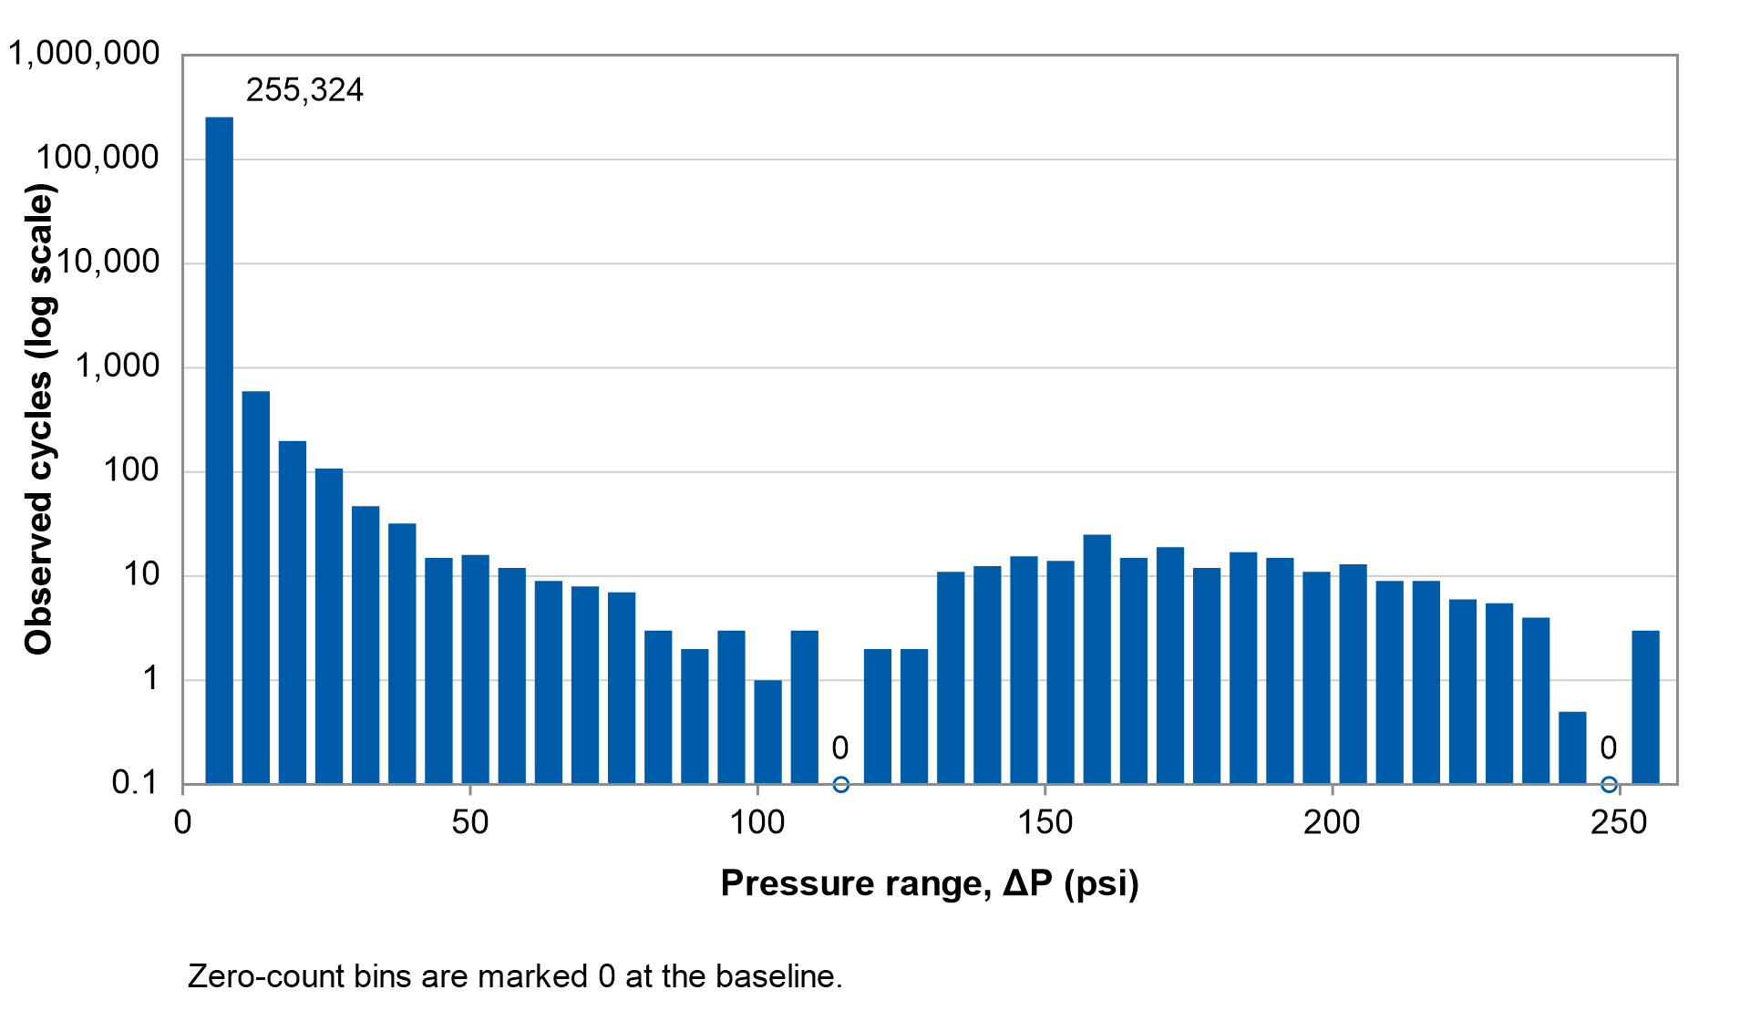
Figure 1: Pressure Cycle Distribution

Data Review

Internal Corrosion
The 2026 ILI reported no internal corrosion anomalies.

External Corrosion
The 2026 ILI reported 8,331 external corrosion anomalies. The maximum reported depth was 79% wt, associated with two anomalies at log distances 929.973 m and 1,503.851 m.

The distribution of reported external corrosion anomalies is shown in Figure 2, with respect to depth, orientation and pipeline elevation.

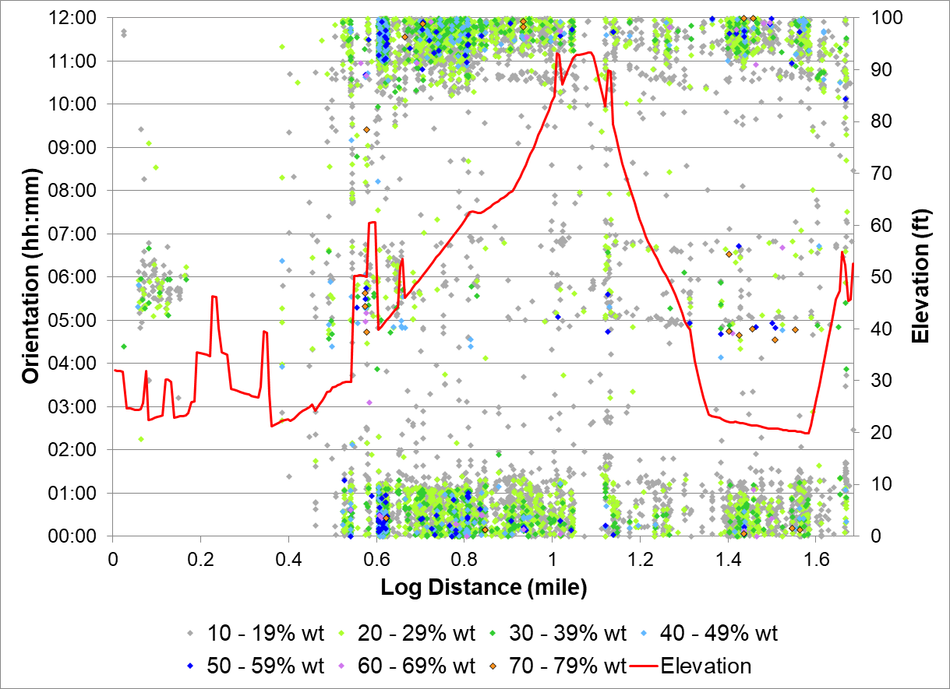
Figure 2: External Corrosion, Depth, Orientation & Elevation vs. Log Distance
Figure 2 shows that most external corrosion is concentrated around the 12:00 position, with a smaller population around 06:00.

Non-Corrosion Metal Loss
The 2026 ILI reported 61 non-corrosion metal loss anomalies, all classified as manufacturing anomalies. The maximum reported depth was 34% wt, associated with an anomaly at log distance 2,489.367 m.
The distribution of reported non-corrosion metal loss anomalies is shown in Figure 3, with respect to depth, orientation and pipeline elevation.

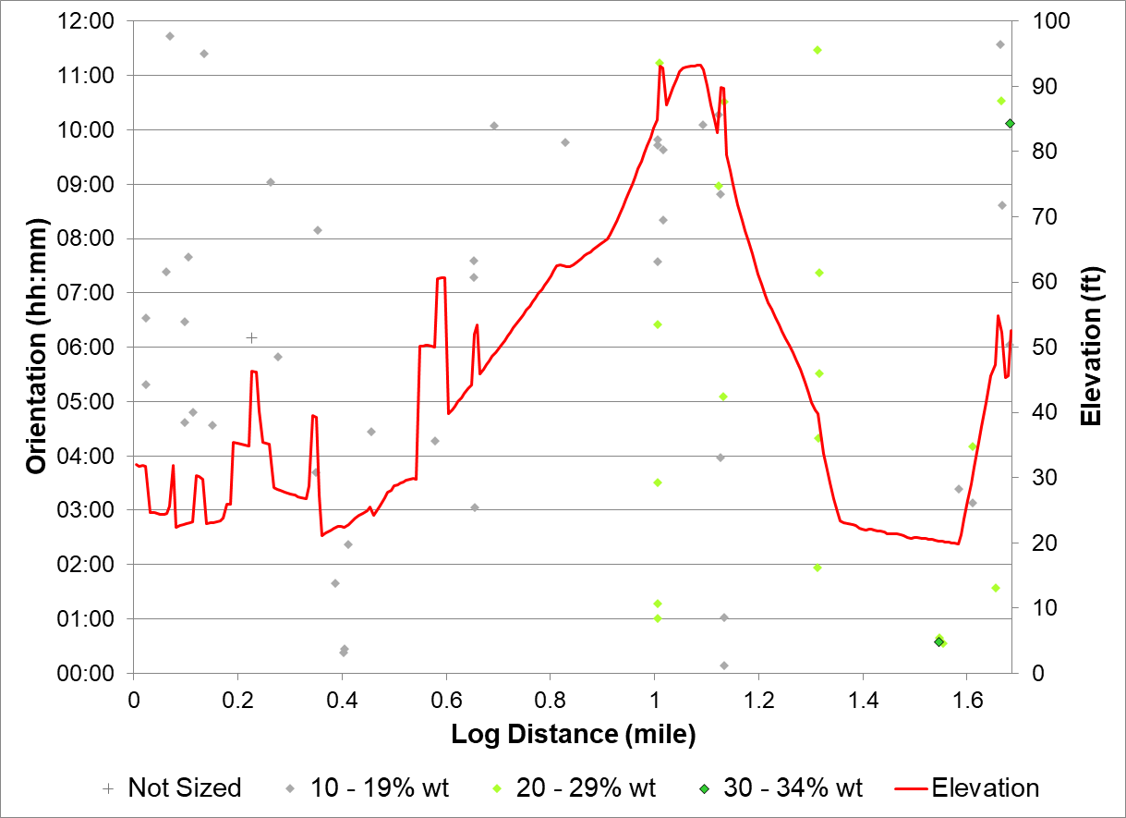
Figure 3: Non-Corrosion Metal Loss Anomalies; Depth, Orientation & Elevation vs. Log Distance
Figure 3 shows that manufacturing anomalies occur at varying positions around the pipe circumference and along the pipeline. The chart also includes two manufacturing indications without reported depth.

Geometric Anomalies
The 2026 ILI reported 196 geometric anomalies, comprising:
- 196 dents, the maximum reported OD reduction was 3.6%, associated with an anomaly at log distance 2,227.434 m.
The distribution of reported geometric anomalies is shown in Figure 4, with respect to centre orientation and elevation.
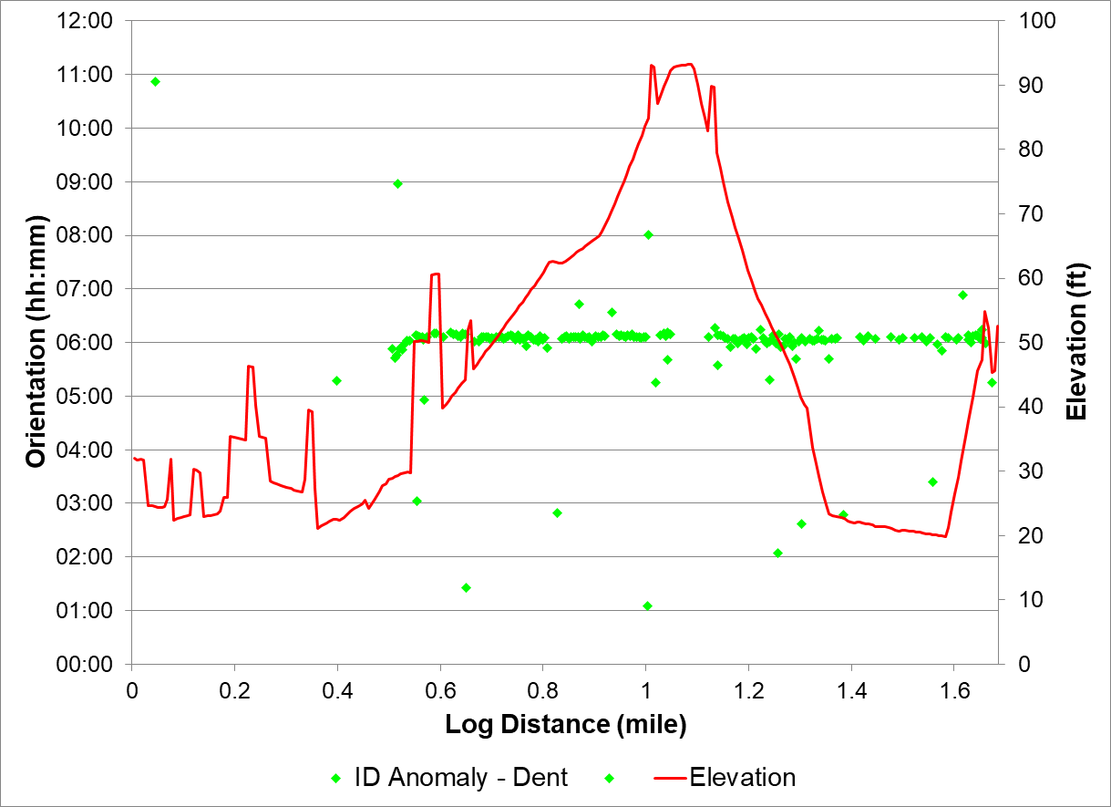
Figure 4: Geometric Anomalies; Centre Orientation & Elevation vs. Log Distance
Figure 4 shows that most dents are concentrated near the 06:00 position.

Laminations
The 2026 ILI reported 30 laminations.

The distribution of reported laminations is shown in Figure 5, with respect to orientation and elevation.

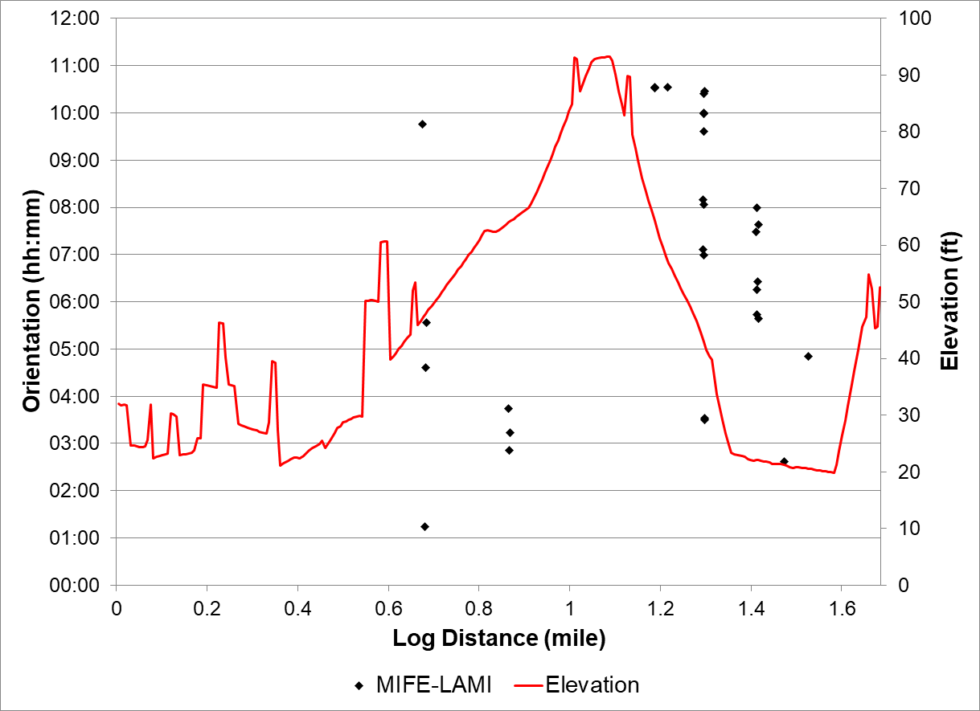
Figure 5: Laminations; Orientation & Elevation vs. Log Distance

ILI Comparison

CGA^{pro} with Box Matching & Signal Comparison
Section 2.1 of the ROSEN Standard Methodology Document for FFP and CGA Services [2] defines the box‑matching method used to compare volumetric metal loss anomalies, with the associated signal comparison classifications (e.g. No Clear Growth, Existing Growth, New Growth) summarised in Section 2.1.2.

Variations in reported anomaly counts and depths between repeat ILI runs may be related to real change due to corrosion growth over the inspection interval, however, variations may also arise due to differences in; run conditions, tool performance, inspection technology, data processing and repairs.

Key metrics of each ILI within the comparison are presented in Table 7 and Figure 6; with the aligned comparison records displayed in Figure 7 (reported depth vs. log distance).
The frequency chart includes all sized metal-loss anomalies in the pipe tallies. The aligned comparison plot excludes the replacement interval from 901.182 ft to 2,027.264 ft and contains 8,388 anomalies from the 2026 ILI and 7,786 historical matches representing 4,498 distinct anomalies from the 2020 ILI.
Table 7: Summary of Key ILI Metrics
Value | 2026 ILI | 2020 ILI
No. Individual Metal Loss Anomalies Reported | 8,392 | 4,828
Maximum Reported Depth | 79% wt | 79% wt
Reporting Threshold | 10% wt | 10% wt

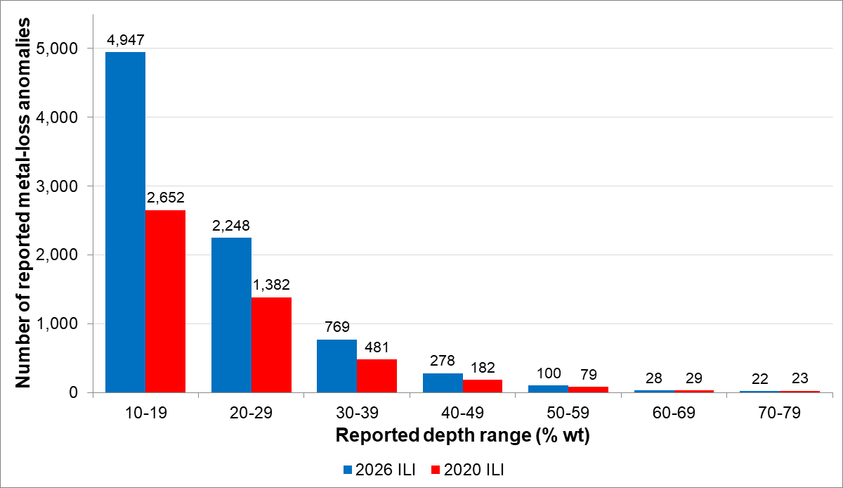
Figure 6: Comparison of Reported Anomaly Depths; Anomaly Frequency vs. Depth
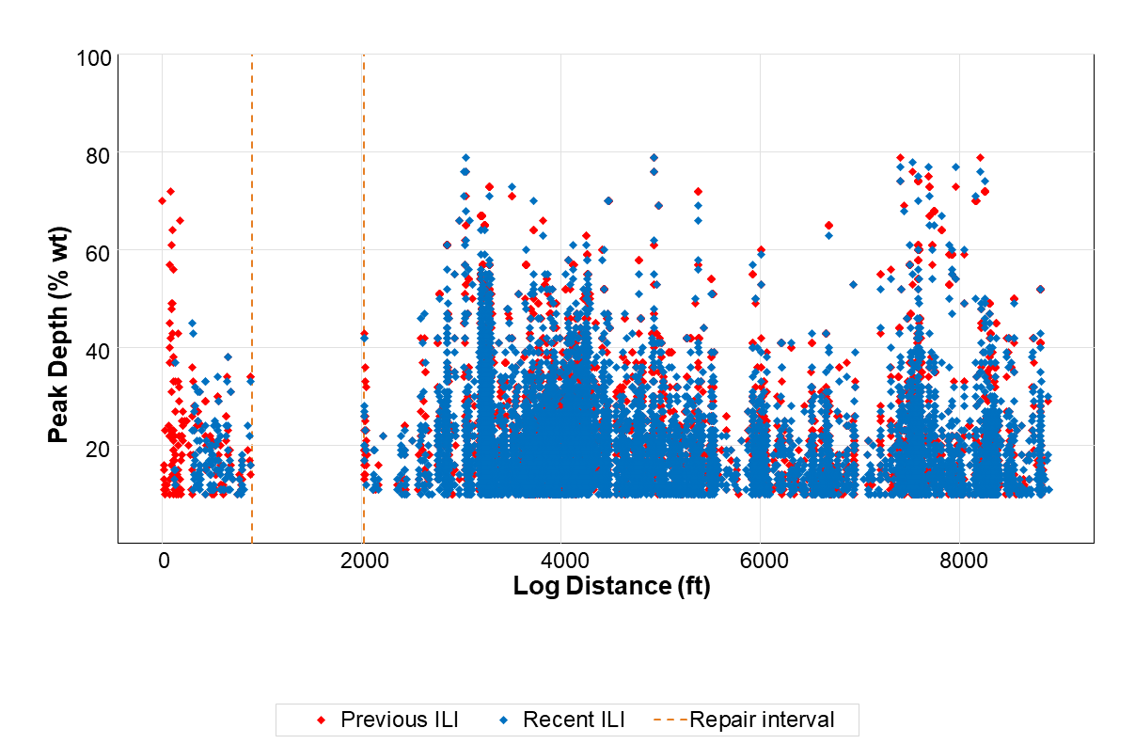
Figure 7: Comparison of Reported Anomaly Depths; Depth vs. Aligned Log Distance

Internal Corrosion
The 2026 ILI reported no internal corrosion anomalies.

External Corrosion

ILI Comparison: Box Matching & Signal Comparison
A summary of the results of the CGA^{pro} is shown in Table 8, with anomaly counts for each box matching classification (matched / unmatched), classifications for anomalies reviewed by signal comparison (in terms of growth observations at the signal level) and maximum associated CGRs.
Table 8: Summary of External Corrosion ILI Comparison Results
Result | Number of Anomalies | Maximum CGR  (mils/year)
Box Matching Only:
Matched | 7,561 | 16.8
Unmatched | 744 | n/a
Signal Comparison:
New Growth | 2 | 20.0
Existing Growth | 5 | 21.8
Possible Growth | 2 | 4.2
No Clear Growth | 17 | n/a
Inconclusive | 0 | n/a
Total | 8,331 | 21.8

An example signal comparison is shown in Figure 8, associated with a 45% wt anomaly at log distance 302.839 ft; showing clear evidence of existing corrosion growth, with the reported depth increasing from 10% wt in 2020 to 45% wt in 2026.

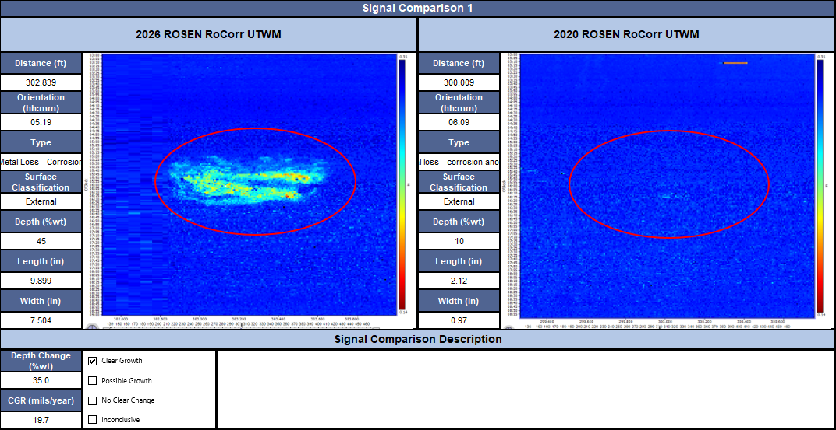
Figure 8: Signal Comparison; 45% wt External Corrosion Anomaly at Log Distance 302.839 ft (2026), CGR of 19.7 mils/year

Recommended Corrosion Growth Rates

Selection of Representative Anomalies
Only anomalies with CGRs considered representative of corrosion behaviour over the ILI interval are included in the segmentation analysis. The plotted external-corrosion population excludes 3,844 anomalies: 1,163 sleeve-associated anomalies and 2,681 unused matches. Four anomalies were assigned individual outlier rates. The comparison and repair classifications are recorded in the associated Excel listing: 'NPS 24 Refinery to Dock #1 Bunker Pipeline (24BUNKER)_CGApro_BM_Listing_Rev0.xlsx'.

Segmentation Results
The segmentation followed the process detailed in Section 2.3 of the ROSEN Standard Methodology Document for FFP and CGA Services [2]. Results are shown in Figure 9 and Table 9; with outlier anomalies listed in Table 10.

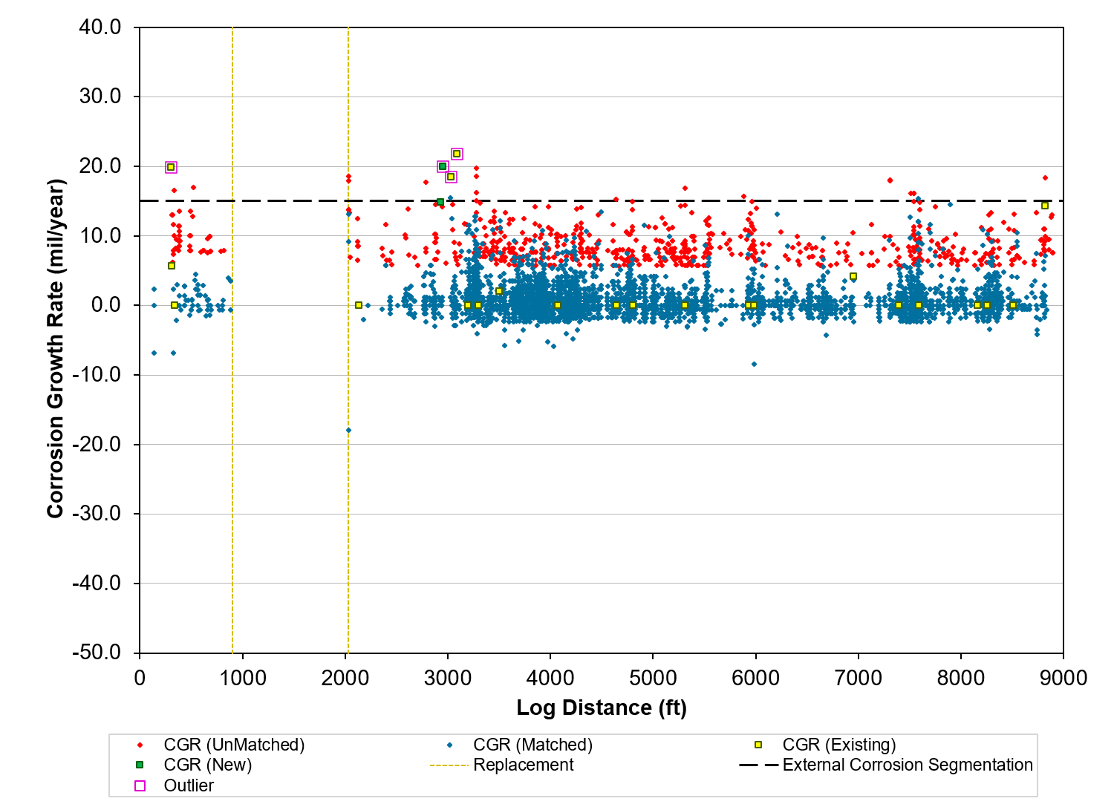
Figure 9: External Corrosion Segmentation; CGR vs. Log Distance

Table 9: External Corrosion Segmentation Results
Segment ID | Start Log Distance  (ft) | End Log Distance  (ft) | Recommended CGR  (mils/year)
EC1 | -5.648 | 8,900.482 | 14.9

Table 10: External Corrosion Anomalies, Details of Outliers
Anomaly ID | Log Distance  (ft) | Joint No. | Orientation  (hh:mm) | Depth  (% wt) | Individual CGR  (mils/year)
65 | 302.839 | 260 | 05:19 | 45 | 19.9
899 | 2,946.009 | 1890 | 05:33 | 34 | 20.0
919 | 3,028.815 | 1910 | 05:38 | 76 | 18.5
1032 | 3,083.343 | 1960 | 03:06 | 66 | 21.8

Non-Corrosion Metal Loss

ILI Comparison: Box Matching and Signal Comparison
The signal comparisons indicate that two of the four reviewed non-corrosion metal-loss anomalies show no clear depth change between inspections (Signal Comparisons 4 and 22). Signal Comparison 20 indicates possible growth for Feature 6466, while Signal Comparison 29 is inconclusive for Feature 9532.

Geometric Anomalies
All geometric anomalies reported by the 2026 ILI were included within the ILI comparison via the box matching process. The results of which are summarised in Table 11.
Table 11: Comparison of Geometric Anomalies
Anomaly Type | Total Number of Anomalies | Number Matched  to Previous ILI | Number Not Matched  to Previous ILI
Dents | 196 | 180 | 16

All 16 unmatched dents were reviewed in the 2020 ILI signal data and were found to show similar indications, indicating that they were present during the previous inspection.

FFP Assessment Summary

Metal Loss Anomalies
The ROSEN Standard Methodology Document for FFP and CGA Services [2] Section 1 outlines the methodology for assessing volumetric metal loss anomalies. The assessment parameters are summarised in Table 2 and Table 12.
Table 12: Summary of the Key Assessment Parameters
Pipeline Section | Start Log Distance  (ft) | End Log Distance  (ft) | Assessment Pressure [4] | Safety Factor
Entire Section | -5.648 | 8,900.482 | 23.17 bar | 1.28(Modified ASME B31G)

Non-Metal Loss Anomalies
A summary of the standard ROSEN assessment methodologies applied to the reported non-metal loss anomalies is provided in Table 13.
Table 13: Non-Metal Loss Anomaly Assessment Summary
Anomaly Type | Assessment Methodology | Relevant Section in ROSEN Standard Methodology Document for FFP and CGA Services [2]
Dents | Depth based static, fatigue, strain | 3.1
Ovalities | Screening to AS/NZS 2885.1 | 3.2
Wrinkles / Buckles / Ripples | ASME B31.8 assessment criteria | 3.3
Laminations | Screening to API 579 | 6

Metal Loss Integrity Assessment

Immediate Integrity Assessment
The safe remaining ligament (SRL) and safe working pressure (SWP) were calculated for each metal loss anomaly using the local assessment parameters and the methodology referenced in Section 1 of ROSEN Standard Methodology Document for FFP and CGA Services [2]. Results showing anomaly SRL OR SWP are presented in Figure 10.

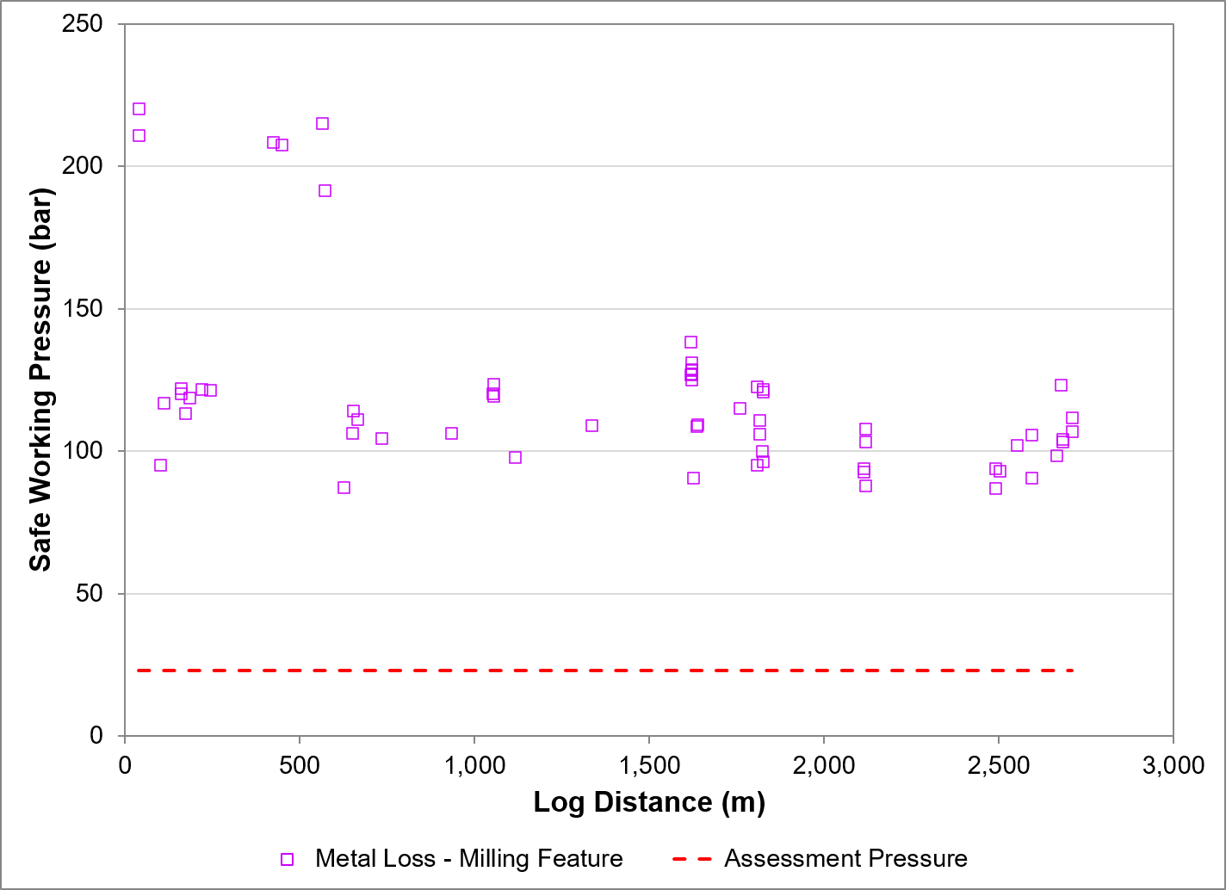

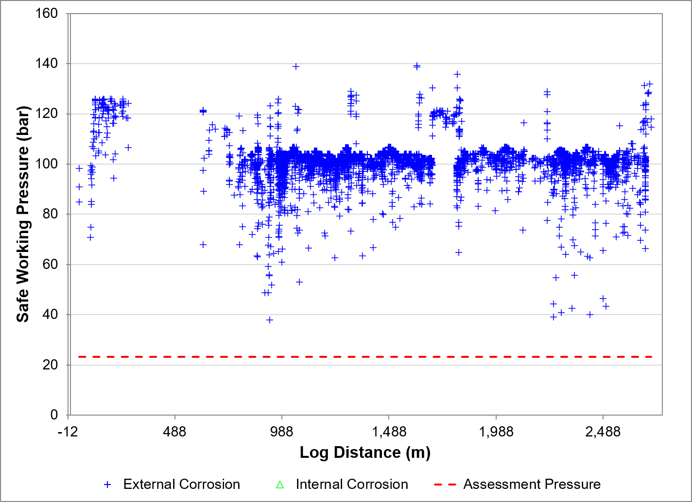
Figure 10: Metal Loss Anomalies; SRL/ OR SWP vs. Log Distance
All reported metal loss anomalies were acceptable for operation at the assessment pressure, considering their axial, circumferential and depth dimensions at the time of the RECENT_YEAR ILI. OR The assessment identified X anomalies which fail the immediate integrity assessment which require investigation / repair. Details of these anomalies are provided in Table 14 and the associated Excel listing: 'XXAAABBB_Repair_Listing_Rev0.xls'.
Table 14: Immediate Investigation / Repair Summary
Anomaly ID | Log Distance  (m) | Event | Surface Location | Joint No. | Reported Depth  (% wt) | Comment

Geometric Integrity Assessment

Immediate Integrity Assessment
The ROSEN Standard Methodology Document for FFP and CGA Services [2] Section 3 outlines the methodology for assessing geometric anomalies, to determine their significance in relation to the immediate integrity of the pipeline.

All anomalies were considered acceptable in accordance with their specific criteria, no further actions are required. OR Immediate integrity assessment results and associated recommended actions are provided in Table 15.
Table 15: Geometric Anomalies; Immediate Assessment Results
Anomaly Type | Assessment Criteria | Number of Anomalies | Action / Recommendation
Any Dent | Buried TOL | X | Determine risk of external interference damage and perform a gouging susceptibility study using ILI signal data and other complementary data sets.  Monitor if low likelihood of external interference.  If high likelihood, carry out a local targeted above-ground coating survey to determine the presence of any damage to the coating.  Excavate if coating damage identified. Repair if excavation confirms associated mechanical damage.
Any Dent | L/d or W/d < 20 | X  (X TOL) | Complete strain-based assessment or in-field investigation.
Dent Not Associated with Weld | >7% OD or Complex Geometry | X  (X TOL)  (X Sharp) | Complete strain-based assessment or in-field investigation.
Dent  On Weld | ≤2% OD | X  (X TOL)  (X Sharp) | Consult records to confirm if weld is ductile. Repair if weld is brittle.
Dent  On Weld | >2% OD or Complex Geometry | X  (X TOL)  (X Sharp) | Consult records to confirm if weld is ductile. Repair if weld is brittle.  Complete strain-based assessment or in-field investigation.
Dent with Corrosion | Corrosion >40% wt or not acceptable according to metal loss assessment | X  (X TOL)  (X Sharp) | Investigate in-field and repair if:  Associated mechanical damage confirmed.  Corrosion confirmed as unacceptable.
Dent with Possible Mechanical Damage | Any | X  (X TOL)  (X Sharp) | Investigate in-field and repair if associated mechanical damage confirmed.
Ovality | Min ID <95% Nominal ID or in an area of instability | X | Assess further to determine significance on the immediate and future integrity of the pipeline or in-field investigation.
Buckle | Any | X | Assess further to determine significance on the immediate and future integrity of the pipeline or in-field investigation.
Bulge | Any | X | Assess further to determine significance on the immediate and future integrity of the pipeline or in-field investigation.
Enlargement | Any | X | Assess further to determine significance on the immediate and future integrity of the pipeline or in-field investigation.
Wrinkle / Ripple | Exceeds allowable height limit, interacts with metal loss or weld or located in area of instability | X | Assess further to determine significance on the immediate and future integrity of the pipeline or in₋field investigation.

The reported geometric anomalies were assessed under static conditions. If the pipeline is subject to significant internal pressure cycling, a fatigue assessment should be considered.

Details of all geometric anomalies which require further actions are summarised in the associated Excel listing: 'XXAAABBB_Repair_Listing_Rev0.xls'.

Lamination Integrity Assessment

Immediate Integrity Assessment
Laminations were assessed following API 579 Part 13 (see ROSEN Standard Methodology Document for FFP and CGA Services [2] Section 6), to determine their significance in relation to the immediate integrity of the pipeline.

All anomalies were assessed as acceptable in accordance with their specific criteria, no further actions are required. OR Recommended actions are provided in Table 16.
Table 16: Lamination Assessment Results
Assessment Criteria | Number of Laminations | Actions / Recommendations
Sloping/Surface Breaking | XX | Assess as crack-like flaws.  API 579 requires that all surface‑breaking or sloping laminations are assessed as crack‑like flaws.
Associated with Welds and/or Major Structural Discontinuities | XX | Desk‑Based Loading Review:  CLIENT SHORT should confirm whether axial loading is a credible threat at lamination locations. Where no threat exists, further action is generally unnecessary.  Targeted Investigation Where Needed:  If axial loading is identified as a potential concern, further review of crossings, existing mitigation, and geotechnical factors may be required. Field investigation should be focused on locations with the highest susceptibility.
Laminations with Metal Loss | XX | Using the API 579 interaction criteria, XX were interacting with metal loss at the time of the RECENT_YEAR ILI.  X were considered unacceptable when assessed with combined dimensions (see Section 5).

The reported laminations were assessed under static conditions. If the pipeline is subject to significant internal pressure cycling, a fatigue assessment should be considered.

Details of the anomalies requiring further action are provided in the accompanying Excel listing: 'XXAAABBB_Repair_Listing_Rev0.xls'.

CSA Z662-23 CoMPLIANCE REVIEW

Compliance Summary - Evaluation of Imperfections

Non Compliance Anomaly Listing

Anomaly Investigation

Anomaly Investigation Listing

Integrity Management Summary

Mitigation Strategy
As outlined in the scope of work, the following sections identify mitigation actions considered appropriate for managing corrosion threats for the pipeline based on the ILI results, FFP assessment, and CGA^{pro} findings, and additional supporting data.

Internal Corrosion
Assessment of the ILI data, in combination with operational information and the CGA^{pro}/FFP findings, indicates an active internal corrosion threat. It is recommended that CLIENT SHORT implement appropriate mitigation measures, which may include…. OR Based on the results of the ILI and CGA the threat of internal corrosion appears to have been well controlled over the inspection interval.

External Corrosion
Assessment of the ILI data, and the CGA/FFP findings, indicates that external corrosion has been an active threat over the ILI interval. External corrosion is primarily governed by coating condition, CP performance, and local environmental exposure. It is recommended that CLIENT SHORT … OR Based on the ILI results and supporting integrity data, the current external corrosion threat is considered to be low. Routine CP monitoring and coating condition surveys in combination with ILI and fitness-for-purpose evaluations are required to continue to mitigate and monitor the threat of external corrosion.

Repair Plan
A summary of anomalies which are predicted to require investigation/repair within X-years of the RECENT_YEAR ILI is shown in Table 17 and Figure 11; further details of anomalies are provided in the associated Excel listing: 'XXAAABBB_Repair_Listing_Rev0.xls' which can be used to develop a full repair plan.
Table 17: Predicted Investigations/Repairs Within X-years of the RECENT_YEAR ILI
Anomaly Type | Investigation/Repair Date |  |  |  |  |  | Total
Anomaly Type | Immediate | 20XX | 20XX | 20XX | 20XX | 20XX | Total
Internal Corrosion
External Corrosion
Non-Corrosion Metal Loss Anomaly
Geometric Anomaly
Lamination
Total

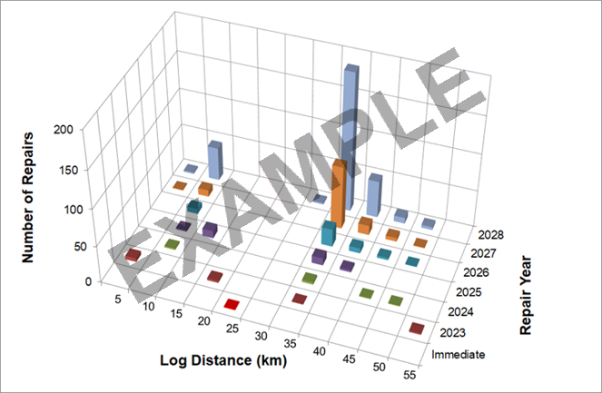
Figure 11: Predicted Number of Future Investigations/Repairs Per Year by Log Distance

Sectional Repair Plan
A sectional repair plan has been developed to optimise mobilisations by grouping anomalies predicted to require investigation or repair. This approach reduces total mobilisation, excavation, and repair costs across the pipeline.

For this analysis, Type B repair sleeves (maximum length 1.22 m / 48") are assumed as the default method for individual anomaly repairs. Where the spacing between anomalies on the future repair list is less than 1.22 m, the entire section is recommended for repair using a single sleeve. Where adjacent anomalies are more widely spaced, they are grouped and assigned an alternative suitable repair method (e.g., composite wrap, cut-out).

The analysis concluded that XX individual anomalies requiring remediation within X-years can be addressed within XX mobilisation/excavation events.

Reinspection and Reassessment
This section considers the timing for future ILI and appropriate tool technology. The recommended inspection interval is predominately based on the potential of corrosion growth. Therefore, this section does not consider potential reinspections which may be required for monitoring other threats such as geometric deformations and pipeline movement. CLIENT SHORT should consider reinspection options for all other relevant threats.

A total of XX anomalies are predicted to require investigation/repair within X-years of the RECENT_YEAR inspection (i.e. before XXX). After X years, the rate at which predicted investigations/repairs are required starts to increase. A maximum reinspection interval of X years is recommended, i.e. reinspect before X.

It is recommended that similar inspection technology is used during the next ILI (i.e. an axial field MFL tool), this will allow like-for-like comparison of the raw signal data and will minimise the uncertainty in CGR predictions.

Reinspection followed by repeat FFP and CGA will reconfirm the corrosion distribution within the pipeline and enable the CGR to be reassessed to demonstrate the effectiveness of the current corrosion control strategy and recalculate the remaining life of the pipeline. This will support the safe, long-term operation of the pipeline.

If CLIENT SHORT finds evidence from in-field investigations or monitoring results (e.g. product monitoring, above ground surveys) to suggest that the predicted CGRs used in this study are not conservative, then the investigation/repair schedule should be redefined on the basis of increased CGR. In addition, consideration should be given to reducing the reinspection interval accordingly.

References

[1] | ROSEN, “ROSEN Proposal Title,” Date.
[2] | ROSEN, ROSEN STANDARD METHODOLOGY DOCUMENT FFP AND CGA SERVICES:, Rev 2026_0.
[3] | VENDOR, “ILI FR 1”.
[4] | A. Author, “Questionnaire.xlsx,” Excel file via Email from A. Author, Client to B. Author, ROSEN, Date.
[5] | VENDOR, “ILI FR 2”.
[6] | American Society of Mechanical Engineers, “ASME B31.4 Pipeline Transportation Systems for Liquids and Slurries,” December 2022.

- Scope of Work
The scope of work is to perform an FFP and CGA based upon the findings of the RECENT_YEAR and PREVIOUS_YEAR ILI [1].The assessment methodologies used are outlined in the ROSEN Standard Methodology Document for FFP and CGA Services [2].
- Review the ILI data and provide a breakdown of the main anomalies relevant to the study (anomaly distribution, changes in pipe characteristics, repairs / replacements, etc.).
- Review the ILI data along with other available pipeline survey data (product data, cathodic protection data etc.) to identify the likely corrosion mechanisms.
- Conduct a distance and joint number correlation to align the 2 ILI data sets.
- Compare the recent and previous anomaly lists using proprietary box matching software.
- Based on the box matching results, make an initial estimate of the historical CGR for each corrosion anomaly reported by the recent ILI (based on reported depths).
- Conduct a manual signal comparison for a sample of up to XX selected anomalies, to verify the box matching results.
- For the anomalies included in the signal comparisons, identify any evidence (or otherwise) of corrosion growth and update the historical CGRs where appropriate.
- Split the pipeline into segments using a semi‑automated segmentation process (note, a unique segmentation will be produced for internal and external corrosion), based on the results of:
- DBSCAN – Used to split the reported corrosion anomalies into ‘concentrations’ and isolated, less dense areas of corrosion (‘noise’).
- Pipe Tally Analysis – Review of the ILI pipe tally / design construction data to identify changes in pipe parameters that may impact corrosion susceptibility.
- Recommend a characteristic CGR to be assigned to the corrosion anomalies in each defined segment.
- Identify any other changes in the pipeline, e.g. dents introduced between the 2 ILI runs. This is limited to identifying new geometric anomalies and does not aim to identify/rule out any change in deformation shape.
- Assess the significance of the corrosion anomalies and any other metal loss anomalies reported in the pipeline, at a pre-agreed assessment pressure.
- Identify any anomalies requiring remediation in accordance with relevant industry guidance at the time of the recent ILI.
- Provide the technical basis for establishing a repair plan for X-years to support the future safe and cost-effective operation.
- Identify an appropriate reinspection interval.
- Document the findings in a written report and spreadsheet listing.

Counts comprise individual sized corrosion and non-corrosion metal-loss anomalies in the corresponding pipe tallies and exclude unsized indications.
This includes 3,351 unused recent matches where a single anomaly from the previous inspection matched multiple anomalies in the recent inspection. The growth rate for the deepest recent anomaly is considered the valid match, while rates from unused matches were excluded from segmentation.
Anomalies not detected in the 2020 ILI signal data, i.e. any anomaly which appears to have initiated after the 2020 inspection.
The CGRs for anomalies showing no evidence of growth in the signal comparisons were set to zero.
The Modified ASME B31G calculations use safety factors of 1.28 for corrosion anomalies and non-corrosion metal-loss anomalies. The safe working pressure is calculated by dividing the predicted failure pressure by the applicable safety factor. The non-corrosion Shannon and Kastner calculations use a safety factor of 1.28.
For the purposes of this assessment, all ID anomalies were assumed to be dents.
e.g. curvature strain / FEA based Level 3 assessment using Strain Limiting Damage / Ductile Failure Damage Indicator
e.g. kinked / multi-apex / double dents / off axis
e.g. curvature strain / FEA based Level 3 assessment using Strain Limiting Damage / Ductile Failure Damage Indicator
e.g. kinked / multi-apex / double dents / off axis
e.g. curvature strain / FEA based Level 3 assessment using Strain Limiting Damage / Ductile Failure Damage Indicator
e.g. areas of bending strain, pipeline movement or unstable ground
e.g. areas of bending strain, pipeline movement or unstable ground.

